King Fahd University of Petroleum and Minerals
Information and Computer Science Department
SWE-205: ‘Introduction to Software Engineering’ (081)
Final, February 2, 2009
Time: 120 Minutes

Instructor: Dr. Sajjad Mahmood
Name: | Student ID:

Questions | Marks | Your Score
Question # 1 | 25
Question # 2 | 16
Question # 3 | 17
Question # 4 | 18
Question # 5 | 12
Question # 6 | 12
Total | 100

Notes:
- The exam has ….. questions and consist of …… pages.
- You are expected to answer all questions.
- This is a closed book exam.
- Please free to use the back of the page. However, please make sure you indicate this in order for me to not miss it for grading.

- Question 1: True/False & Short Description. [25 Marks]
  - Mark the correct statements as True [T] and the incorrect statements as False [F]
[15 Marks, 1.5 marks each]

1. Ethical behaviour is simply upholding the law. | F
2. Trade secret laws have a 25 years time limitation. | F
3. In strict liability, defendant is held responsible for the injury regardless of their intent or negligence. | T
4. Verification rules are the platform independent representation of Java Binary code. | F
5. Hypertext Mark-up Language (HTML) is not case sensitive. | T
6. The waterfall model has separate and distinct phases of specification and development. | T
7. Software products are the greatest threat to loss of company trade secrets. | F
8. In HTML, ‘GET’ method is a secure method to transmit the data back to the web server for processing. | F
9. Milestones are the end-point of a process activity. | T
10. Dependability means software must evolve to meet changing needs. | F

  - Answer all the following questions by checking all that applies to the statement of the question.
[10 Marks, 2 marks each]

- The four symbols used when developing a Data Flow Diagram are
  - Event, trigger, iteration and join. [ ]
  - Context level 0, level 1, level 2 and level 4. [ ]
  - Process, data flow, data store and external entity. [√ ]
  - Actor, scenario, fragment and visualization. [ ]

- Which of the following statements are true for certification?
  - Certification carries no requirements to adhere to a code of ethics. [√ ]
  - Certification carries requirements to adhere to a code of ethics. [ ]
  - A professional processes a particular set of skills in the option of all certifying organizations. [ ]
  - Establishes an environment that supports ethical behaviour by
users. [ ]

- _____________ models are dynamic models that document, for each mode of interaction, the sequence of object interactions that take place.
  - Class Diagrams. [ ]
  - Sequence Diagrams. [√ ]
  - State Transaction Diagrams. [ ]
  - Use Cases. [ ]

- Patent Laws help
  - Protect abstract ideas. [ ]
  - Protect information critical to an organization. [ ]
  - Protect inventions. [√ ]
  - Prevents independent creation. [√ ]

- Identify the valid personality types that should be taken into account for motivating people.
  - Interaction-oriented people. [√ ]
  - Respect-oriented people. [ ]
  - Consistency-oriented people. [ ]
  - Self-oriented people. [√ ]

- Question 2:
[16 Marks]
- Software testing activities boils down to selecting and executing test cases. Identify three key elements of a test case? [6 Marks]

    - Set of test inputs, of if the program is non-terminating, a sequence of test inputs.
    - Expected results when the inputs are executed; and
    - Execution conditions or execution environments in which the inputs are to be executed.

- Briefly explain Black-Box and White-Box testing techniques.
[6 Marks]
Black-box Testing
Test cases are derived from formal specification of the system. Test cases selection can be done without any reference to the program design or code.

White-Box Testing
Test cases are derived from the internal design specifications or actual code for the program.

- Identify one advantage and one limitation of white-box testing.
[4 Marks]

Advantage
- Tests the internal details of the code; Checks all paths that a program can execute.

Limitation
- Wait until after designing and coding of the program under test in order to select test cases.

- Question 3: Rapid Development
[17 Marks]
  - Briefly discuss, at least two scenarios, when would you recommend against the use of an agile method for developing a software system?
[6 Marks]
(1) Agile method should not be used when the software is being developed by teams who are not co-located. If any of these teams use agile method, it is very difficult to co-ordinate their work with other teams.

(2) Agile method should probability also be avoided for critical systems where the consequences of a specification error are serious. In those circumstances, a system specification that is available before development starts makes a detailed specification analysis possible.

  - Agile method are probably best suited to small/medium sized business systems with a focus on code rather than the design process. Briefly discuss the following three principles of an agile method.
[6 Marks]
    - Customer Involvement
Customers should be closely involved throughout the development process. Their role is provide and prioritise new system requirements and to evaluate the iterations of the system.

    - People not process
The skills of the development team should be recognised and exploited. Team members should be left to develop their own ways of working without prescriptive processes.

    - Embrace change

Expect the system requirements to change, so design the system to accommodate theses changes.

  - Identify five key points that are important for giving good oral presentations.
[5 Marks]
(1) Formulate a strategy
(2) Choose an appropriate structure
(3) Create visual aids to enhance your presentation
(4) Strive for effective and natural delivery
(5) Handle Q & A effectively

- Question 4: [18 Marks]
  - Imagine yourself navigating “http://www.kfupm.edu.sa/” on one of your favourite web browsers. Explain the four key steps involving in navigating the above web site.
[8 Marks]
- The browser software access Domain Name System (DNS), which converts the registered URL into IP address.
- Browser opens a socket connection (typically port 80), and sends the HTTP request to the default page at the KFUPM website.
- Hosting web server receives the incoming HTTP request, may use client supplied input to format a proper HTTP response or dynamically generate content.
- Finally, client renders the HTML received from the web server.

  - Identify at least three factors that should be taken into account when selecting staff to work on a software development project?
[6 Marks]
Key factors are experience with the domain, platform and tools, personality of the individuals, in particular their ability to fit into an existing team and their communication skills.

  - Suggest which of the factors identified in Question 4 (b) would be most important in choosing staff for an embedded real-time systems development project to develop a controller for an eye surgery machine.
[4 Marks]

For an eye surgery machine, the system is safely critical so domain and platform experience is particularly important as inexperienced staff are liable to miss critical features that could affect the safely of the system. Team working ability and the ability to response constructively to criticism are also important as reviews are an essential part of critical systems developments.

- Question 5:
[12 Marks]

‘Imaginary Bank’ needs a software to be developed that will control an Automated Teller Machine (ATM) having a magnetic stripe reader for reading an ATM card, a customer console (keyboard and display) for interaction with the customer, a slot for depositing envelopes, a dispenser for cash (in multiplies of SR 10), a printer for printing customer receipts, and a key-operated switch to allow an operator to start or stop the machine. The ATM will communicate with the bank’s server over an appropriate communication link (the software on the latter is not part of the requirements for this problem).

The ATM will service one customer at a time. A customer will be required to insert an ATM card and enter a personal identification number (PIN) – both of which will be sent to the bank for validation as part of each transaction. The customer will then be able to perform one or more transactions. The card will be retained in the machine until the customer indicates that he/she desires no further transactions, at which point it will be returned.

A customer must be able to make a cash withdrawal from any suitable account linked to the card. Approval must be obtained from the bank before cash is dispensed. A customer must be able to make a deposit to any account linked to the card, consisting of cash in an envelope. The customer must enter the amount of the deposit into the ATM, subject to manual verification by an operator. A customer must be able to make a transfer of money between any two accounts linked to the card. Furthermore, a customer must be able to make a balance inquiry of any account linked to the card.

  - Identify Actors and Use cases [6 Marks]
  - Draw a UML Use Case Diagram [6 Marks]

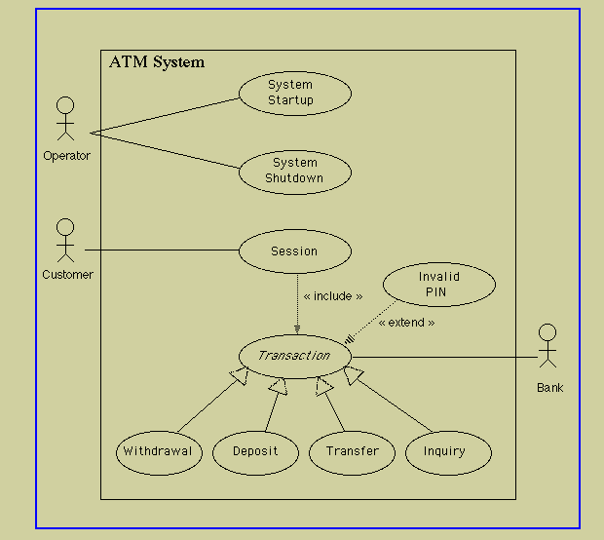

- Question 6:
[12 Marks]
  - “A group of diary and time management system in intended to support the timetabling of meetings and appointments across a group of co-workers. When an appointment is to be made that involves a number of people, the system finds a common slot in each of their diaries and arranges the appointment for that time. If no common slots are available, it interacts with the user to rearrange his or her personal diary to make room for the appointment.

Identify possible objects (including attributes and operations) in the above system and develop an object-oriented design for them.
[8 Marks]

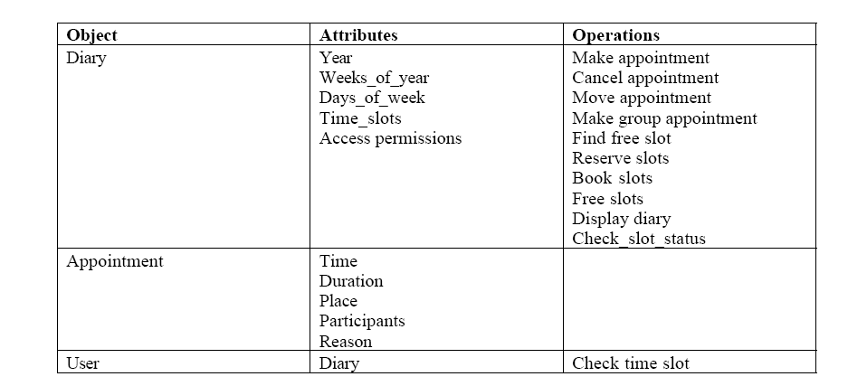

  - Using an example, explain the difference between an object and an object class.
[4 Marks]
An object class is a generic description of a set of entities (or objects) which have a common characteristic and which are recognisably the same in some or all respects.

Objects are specific instances in the real world or in a system where values have been assigned to the characteristics defined in the object class.

